VOLUNTEER HANDBOOK

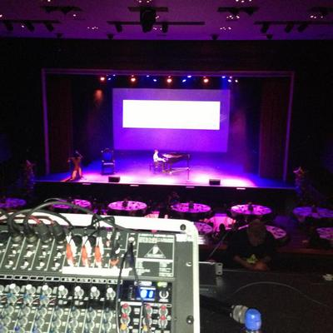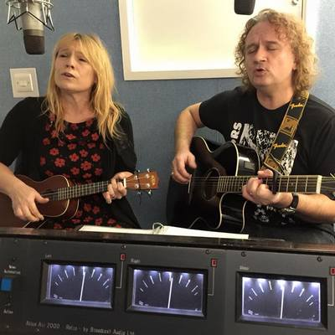
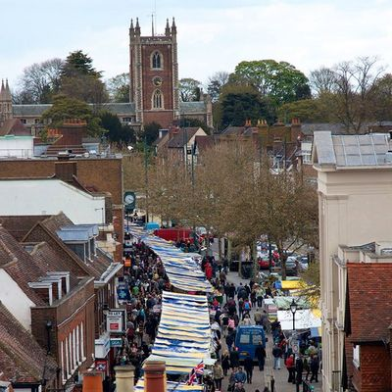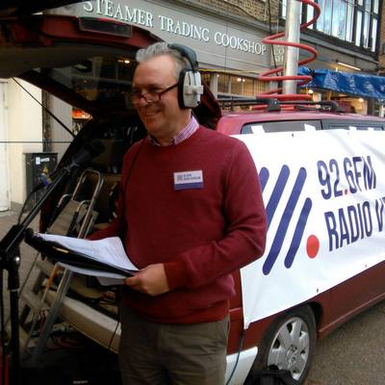

Why?
We have put this Volunteer Handbook together to help you understand what we do, how we do it and how you can get the most out of volunteering with us.

Your experience
We want to make sure that your experience with us is a very positive one and that we get the best out of your valuable time and background. We value our volunteers and we are keen to make sure your feel valued and able to make a real contribution to the radio station and our community.
We know that volunteers can contribute in many ways, that their contribution is unique and that volunteering can benefit our community and the volunteers themselves.
We value the contribution made by volunteers and is committed to involving volunteers in appropriate positions and in ways which are encouraging, supportive and which develop volunteering.
We recognise our responsibility to arrange volunteering efficiently and sensitively so that the valuable gift of the volunteer's time is best used to the mutual advantage of all concerned.

What we do and why
Radio Verulam is a not for profit community radio station.
Our mission is:
To enhance the daily lives of all sections of the community in our area by providing news, information and entertainment.
Our vision is:
To become a widely known and listened to radio station and internet presence, both of which are recognised within and outside the local community as a professional, engaging and useful service. To form a significant part of the fabric of life in the area, embraced by businesses and individuals as their preferred local radio station
We are passionate about St Albans. We are the radio station for St Albans. We reflect life in our city in a way which no other radio station does. We think that’s exciting and we hope you do too.
We are a company limited by guarantee. The Board of Directors is elected by members of the company. Membership is open to anyone.
Our programmes benefit the local community by informing and educating them about their local area and organisations and individuals who are working to their benefit in many different ways. Many local people representing themselves or organisations have the opportunity to appear on many of our programmes to discuss and publicise their work.
We are particularly proud that we broadcast live from and assist with a number of local events which enrich our community and area, such as:
- The St Albans street festival: An annual council organised event with entertainment for the family and local businesses
- The Hertfordshire County Show: This event is organised annually by a not for profit organisation to showcase the best of the county’s business, having grown from an agricultural show to an event which attracts around 30,000 local residents each year.
- The Mayor’s Pride awards; a three hour live broadcast of the awards ceremony which focusses on local people who have made a difference in their area.
- The Dragon's Apprentice Challenge Awards ceremony from the University of Hertfordshire in Hatfield. This very worthwhile competition organised by the St Albans Council for Voluntary Service sets teams of Lower Sixth formers (16-17 year olds) from local schools the task of raising money through business ventures to give to local charities and voluntary organisations.
Our Key Commitment is to help local community, charitable, social and voluntary organisations to promote themselves and attract new volunteers through the medium of community radio. During a typical year we interview representatives from more than 100 local businesses and organisations on air, and have continued to develop a team of more than 20 regular correspondents covering subjects as diverse as gardening and wildlife, arts, travel, news from the local churches, local medical charities, football, beauty tips, business and interior design.
The What’s On area of our website www.radioverulam.com enables any local organisation to add details of any of their activities or fund-raising events as a promotional tool. This promotion is also available on air free of charge to not for profit organisations.
We try hard to be accountable to our listeners. We receive direct feedback from our listeners in person (especially at local community events and studio Open Days), by social media, email and phone on a daily basis. Our programme Blogs, Facebook pages and Twitter feeds are encouraging direct communications with presenters. This feedback is overwhelmingly positive.

The company
The radio station is a company called “Verulam Community Radio Limited”. This is a company limited by guarantee, which means that we have members who elect a Board of Directors and who can vote on matters such as changes to our purpose and governance (our company articles). You can become a member. See www.radioverulam.com/membership
The Directors are responsible for setting our strategic direction, ensuring the sustainability of our business and managing our finances. They are also responsible for ensuring that what we do complies with laws and regulation. The Directors give up their time unpaid and receive no expenses in relation to their Board duties.
We are a regulated business, primarily by being licenced by Ofcom but also under codes such as the Advertising Standards Authority code. This places a significant responsibility on the Directors for the maintenance of our licence. Without our licence, we would cease to exist. The Directors ensure that through regular volunteer training and proper scrutiny we meet the obligations which Ofcom places upon us. Our level of regulation is very similar to that of much larger station such as Heart.

What to expect from us
We aim to make all volunteers’ experiences positive ones. In particular, you should expect:
- To be treated with respect and fairness
- To have your views heard and listened to
- Your fellow volunteers to work collaboratively with you
- To have opportunities to learn new skills
- A supportive, creative and fun environment
Volunteering is a crucial activity that is supported and encouraged by the organisation and is not intended to be a substitute for paid employment. The role of volunteers complements but does not replace the role of any paid help.
Appropriate steps will be taken to ensure that any paid people are clear about the role of volunteers, and to foster good working relationships between paid people and volunteers.
The volunteer role is a gift relationship, binding only in honour, trust and mutual understanding. No enforceable obligation, contractual or otherwise, can be imposed on volunteers to attend, give or be set a minimum amount of time to carry out the tasks involved in their voluntary activity. Likewise the organisation cannot be compelled to provide either regular tasks, payment or other benefit for any activity undertaken by the volunteer.
Although volunteers offer time freely and willingly without binding obligation, there is a presumption of mutual support and reliability. Reciprocal expectations are acknowledged – both of what we expect of volunteers and what volunteers expect of us.

What we expect
It is important for our volunteering experience and the sustainability of the radio station that we can expect:
- You treat your fellow volunteers with respect and fairness
- You behave responsibly and with due regard to the reputation of the radio station and the company at all times
- You act in the best interests of the radio station and the Company
We also ask that you:
- be reliable
- be honest
- respect confidentiality
- make the most of training and support opportunities
- carry out tasks in a way that reflects the aims and values of the organisation
- carry out tasks within agreed guidelines
- respect the work of the organisation and not bring it into disrepute
- comply with the organisation's policies
- Make a regular volunteering commitment
- Undertake activity in line with the directions given by your team leader, our volunteer manager or the Company
- Undertake activity which helps to sustain the radio station as a whole (for example, handing out leaflets or administrative work, setting up events for us or speaking to local groups on our behalf). There are many such tasks and we will find the ones which suit your desires and skills.
- Let us know if you can’t make pre-arranged times or complete tasks
- Let us know if you feel your expertise is not being well used
- Abide by our policies
- Attend regular training and briefing sessions
- Ensure that you are aware of any health and safety related information
- Take care of yourself while volunteering
- Raise any concerns you have promptly with your team leader

Our teams
The nominated post holder with overall responsibility for the development of voluntary activities within the organisation is the Volunteer manager. This person is responsible for the management and welfare of the organisation's volunteers
We work together as teams, and every volunteer has a Team Leader. You may find that your volunteering spans more than one team; you may have more than one Team Leader.
Team Leaders are the first people to turn to if you are confused, concerned or have ideas about what you or others could be doing to improve what we do.
There is a structure to team leadership and this is set out in The Team Leader Structure on our Intranet, RV:INSIDE. You will be notified of any changes to this structure as they impact you.
The Board is responsible for ensuring that the company and radio station are run in accordance with our mission and vision, within the law and in a financially sustainable way.

What to expect from a team leader
Team Leaders will:
- Help you to do your best in your role
- Listen to ideas, and discuss them with you
- Make clear decisions based on the best interests of the radio station

Recruitment and selection

We are committed to equal opportunities and believe that volunteering should be open to all regardless of race, gender, religion, sexual orientation, political beliefs or offending background that does not create a risk to vulnerable groups including children.
The acceptance of volunteer assistance for a particular role is made on merit, the sole selection criterion being the individual's suitability and willingness to carry out agreed tasks.
Volunteering opportunities will be widely promoted in ways that makes them accessible to all members of the community.
Volunteers who are considered unsuitable for a particular task will either be offered alternative voluntary involvement with the organisation or referred to the Community Central to seek other opportunities.
All volunteers will be asked to produce two references and will be invited to attend an informal interview. If the volunteer will be carrying out activities with vulnerable groups (children and/or adults) there may be other safer recruitment procedures carried out including asking a volunteer to undergo an enhanced Disclosure and Barring Services (DBS) check. More detailed information will be made available specific to legislative requirements and to the particular volunteer position.
Volunteers will have a clear and concise task description, which will be subsequently reviewed every year with their Team Leader. The task description will be prepared in conjunction with the volunteer and the Volunteer Manager.
New volunteers will be properly inducted into the organisation.
Volunteers will be properly briefed about the activities to be undertaken and given all the necessary information to enable them to perform with confidence.

What we expect you to do

Staying safe and well
We maintain public liability and employers insurance so if something goes wrong we may be covered but you are responsible for ensuring that you are properly briefed on any health and safety issues and that you take reasonable care when on our premises or volunteering for us elsewhere. Always identify potential hazards and ways to mitigate them. If you are concerned about anything, speak immediately to any team leader.
Please familiarise yourself with the Health and safety section of this document.

Keeping in touch
Of course, talk to other volunteers and your team leader but also please make sure you are receiving our weekly team update email. This is the most effective way we can find to get information out to everyone in a timely way. You should also join the Radio Verulam Volunteers Facebook group and the WhatsApp group.
Please amend your contact details in the “My Account” section of RV:INSIDE if they change and notify your team leader of any other changes in your circumstances or availability.

When things go wrong
Even when we are all working together as a team, we may not always have the same idea about the best things to do or how to do them. That is why we have team leaders. They are there to make decisions and resolve issues and differences.
If you are unhappy or concerned, talk to your team leader first. If you’re still not content, then we have a formal process which we follow to resolve issues in the best interests of the radio station and company. A copy of this procedure is available on our Intranet, RV:INSIDE.

When your circumstances change
We know time comes and goes, and our commitments change over time. You are a volunteer! You have free choice about what to do with your time and we know that sometimes you’ll need to reduce the time you can spend at the radio station. Or, you might need to leave us. We completely understand. All we ask is that you let us know; please don’t just drift away…it helps us make sure we have things covered. If you can, we’d appreciate it if you could give us some notice. Speak to your team leader or the volunteer manager.

HEALTH AND SAFETY
The Health and Safety policy is managed on behalf of the Company Board by our studio manager.
However, it is your responsibility to ensure you understand the policies and risks and to ask your team leader if you are unsure.
Do not do anything you consider to be unsafe. If anyone asks you to do something you consider unsafe, decline politely and raise the potential issue with your team leader or the volunteer manager.

Fire
Fire exits at our studios are clearly indicated by signs. Take time to familiarise yourself with how you would exit the premises in the event of a fire.
In the event that an alarm sounds in our area or any other area of the building, you should evacuate calmly and quickly. Do not stop to collect personal belongings, and do not concern yourself with our output.
Although fire extinguishers are provided, you should not attempt to tackle a fire. Sound the alarm, ensure that everyone in the area is aware they should evacuate and leave. When you are safe, dial 999.
The fire assembly point is located in the car park at the rear of our premises.
Exit routes are shown below and are:
- Down the stairs and out into the car park or through the café out to the street
- Through the door next to the production workstations using a “break bolt” and into the offices next door to our premises then down stairs and out to the street
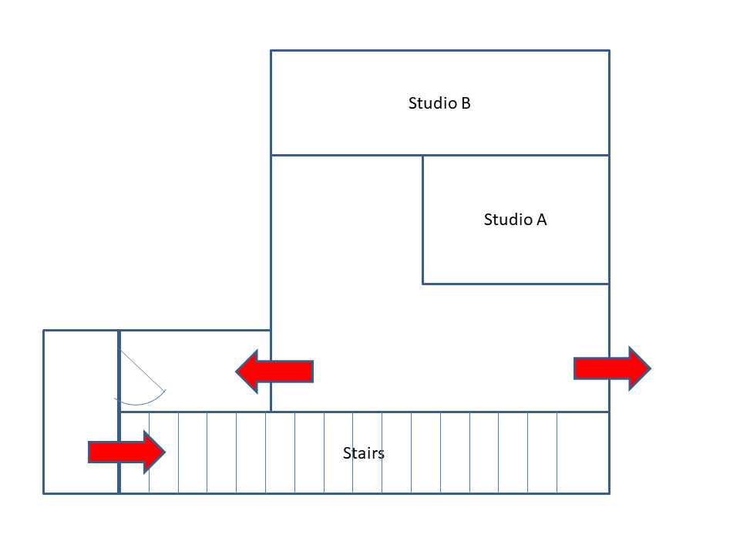
Figure 1 - Upstairs evacuation routes
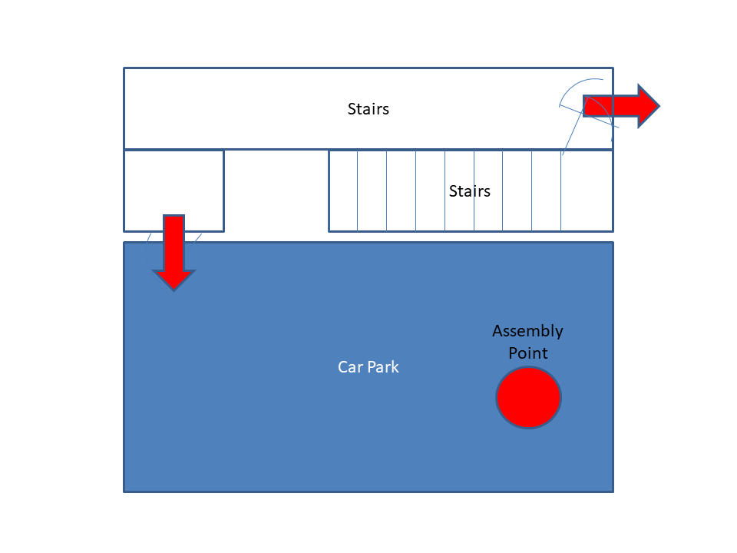
Figure 2 - Downstairs escape routes and assemply point

ACCESS TO THE PREMISES
Keyholders are able to enter the premises unaccompanied. Non-keyholders should not be in the premises unaccompanied at any time.
Doors should be locked on leaving the premises if there is no other keyholder present.
Do not prop open any doors; this creates a fire hazard and a personal safety risk.
Please close the door at the bottom of the stairs at all times as it creates a hazard for café customers if it swings into the corridor.

Reporting risks
If you spot a potential safety risk, please alert people around you to it and then let the studio manager and your team leader know. This is important for the safety of others even if no issue has yet occurred.
The Electricity at Work Act requires everyone to report any electrical defects to the Studio Manager. Please do not touch any studio equipment unless you have been trained to use it.

PERSONAL SAFETY
Please be aware of potential personal safety risks:
- When arriving and leaving, particularly at night, be alert for potential personal safety issues.
- Keep the premises door closed at all times and only admit people who you can be sure have a legitimate reason for entering our premises.
- The stairs are very steep, so take extra care when using them
- When opening the door into the ground floor, please take care not to injure anyone using the corridor.
- Make sure you don’t put boxes or other obstructions in walkways and do not obstruct any exits.
- Do not leave wires trailing across areas where people may walk.
- Take care in the production area; there is a change in floor height; be aware of the step.

Equipment area
Do not go up to the equipment area (on the roof of the studios) unless you have been specifically authorised to do so by either the volunteer manager or the station engineer. There are risks associated with doing so, and you should never access this area without at least one other person present.

Tower
Nobody is permitted to access the church tower where our transmitter is located without written authorisation from the studio manager. There are significant risks and this area is subject to a separate risk assessment and briefing.

OUTSIDE OUR PREMISES
You may often undertake volunteering outside our premises; this could be in the City Centre, elsewhere in our area, at an Outside Broadcast or at your home.
You should, wherever you are working, check for potential health and safety risks and ensure that you avoid them. If you feel that you cannot avoid the risk, you should not undertake the activity and let your team leader know.
Risks can include but may not be limited to:
- Electrical safety issues
- Trip and slip hazards
- Personal safety in relation to working with (for example, interviewing) members of the public.

OUTSIDE BROADCASTS
Outside Broadcasts are a particular area where Health and Safety issues may arise. You should take extra care at Outside Broadcasts. Please:
- Ensure you have received and read the briefing document for the OB. If you have not, ask the team leader for the OB for a copy and read it before you start any activity
- Identify any potential risks, such as trip hazards, trailing cables, power supplies
- Identify any such risks which could impact on members of the public
In setting up and operating equipment at remote locations, please:
- Reduce the risk to members of the public by ensuring there are no trailing cables or equipment in areas where they may walk or be.
- Ensure appropriate electrical safety measures are in place; check this is the case with the OB team leader. They should include the use of earth protection on all power supplies.
- Do not operate any equipment if you have not checked that it is safe
- In the event of wet weather, ensure that all power is safe and, if in any doubt, halt the broadcast or other activity and disconnect the power.
- Make sure that there is no microwave radiation risk from transmitters.

